1.1.1: Key Metric TitleContents

Sl. No. | Item | Page
1. | Formatting guidelines | 1

Formatting Guidelines

- Font: Times New Roman
- Font Size:
  - Title and subheadings: 14pt
  - Contents: 12pt
- Title in bold
- Content alignment - Justify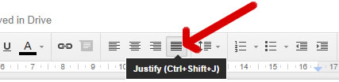
- Line spacing: 1.5pt
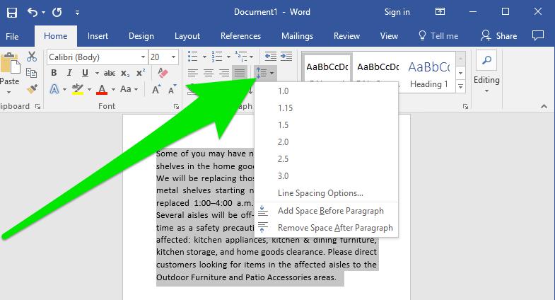
- Add page numbers
- Add watermark in all pages (as in this document)
- Need not make any changes in the header or footer
- Need not add any border

